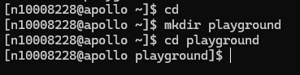
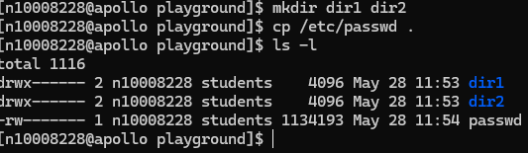

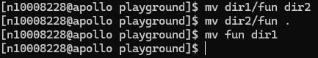
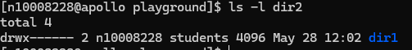


The ls command shows only the files and directories in a compact way on the other hand, ls -l shows them in a long format, displaying detailed information like owner, size, permissions, and last modification date
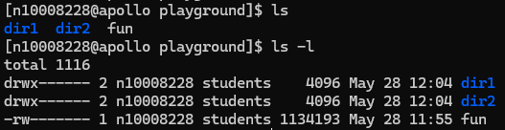
in both cases mv acts like a "rename" command if the second destination doesn't exist yet but if dealing with folders and the second folder already exist the mv command will move the first folder inside the second folder instead of renaming it
